Chebyshev Low Pass Filter Design with Tunable Corner Frequency

Di Sun, Bohan Wang

Abstract—We report a 6th order Chebyshev low pass filter design based on Sallen-Key topology. The low pass filter can be able to tune the corner frequency from 200kHz to 1MHz with a step of 200kHz. The roll-off speed after the corner frequency is 56dB/dec.
Keywords—Sallen-Key;Chevyshev; low pass filter;frequncy tuning

Introduction
Filters have been widely applied for video transmission, wireless communication and data acquisition, which become essential blocks in transceivers and A/D conversion [1]. They will reduce the effect of undesired signal at certain frequency bandwidth and retain desired signal at required pass band. In order to let users to tune the target corner frequency conveniently with different data transmission standards, the filter design should be tunable to support frequencies within certain bandwidth.
There are two main types of filter topologies: passive RLC filter and active filter based on op-amp. For passive filters, there is usually no need for the power supply and there is no limit for the bandwidth. The passive filter is very stable, with least number of components and noise sources. However, passive filters have low Q, no power gain, no voltage gain and loading issues to drive the load. What’s more, large inductors might be required for low frequency applications, which will take much space and is not suitable for integrated circuits. While the active filters with op-amp are power required, susceptible to oscillation, slew rate and gain bandwidth constrained, they showed better performance with high Q and sharp roll-off attenuation with frequency. For active filters, there are no requirements for inductors and they are very convenient to implement in chip form.
In this paper, we implement a 6th order Chebyshev low pass filter with corner frequency tuned from 200kHz to 1MHz. It is designed based on Sallen-Key topology with MOS switches to vary the resistance. The tuning of the corner frequency could be conveniently programmed with microcontroller. The filter is designed in board form with least components and low cost.

Circuit Design

Filter Type and Selection
There are four classic types of high-order filters: Butterworth, Chebyshev, Elliptic and Bessel[2]. Butterworth filters will give the flattest passband with almost no ripple. The roll-off rate is smooth and monolithic as well. Chebyshev will bring better roll-off rate but have more pass band ripple. There is an optimal trade-off between the two parameters. Elliptic will have the steepest roll-off rate but have ripple on both pass band and stop band. However, the phase response is very nonlinear. And Bessel have very smooth transition and phase response, but the roll-off rate between the pass band and the stop band is the smallest.
In our report, we choose to use Chebyshev low pass filter design due to its sharp roll-off rate after corner frequency and acceptable ripple on pass band.

Single Stage Low-pass Salen-Key Filter Design
To realize high-order filter design, there are basically two kinds of strategies: cascade design and direct synthesis [2]. In our approach, we use cascade design by cascading 2nd-order biquad filters. The basic 2nd order low pass Sallen-Key filter is shown in Fig. 1 below.
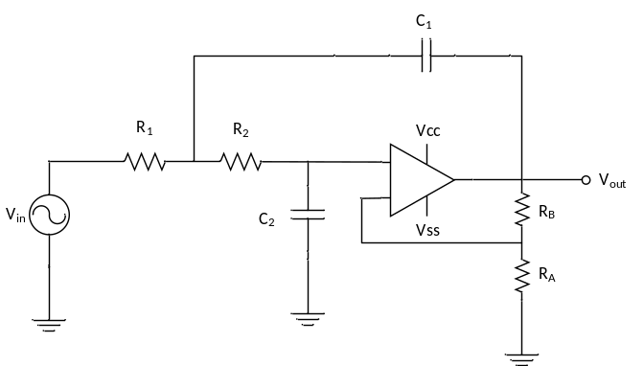
Fig. 1 Low pass Sallen-Key filter with op-amp
For the 2nd order low pass filter, the transfer function H(j) could be derived as the standard form:
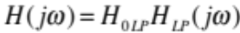
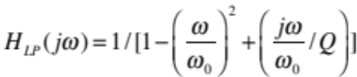
Where H_{0LP} is the dc gain,  is the corner frequency, Q is the quality factor.
The transfer function is derived as:
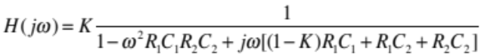
By inspection, we get:
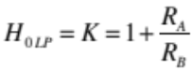, 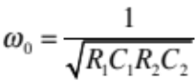
To simplify the design, we can use equal components methods. By letting 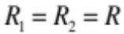 and 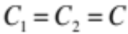 , we get the simplified design equation below:
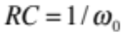, 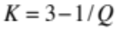, 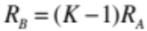

Chebyshev Low Pass Filter Cascade Design
Based on the magnitude Bode plot of the high order low pass filter, the Chebyshev mathematical approximation could be expressed as:
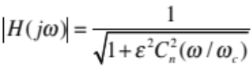
where 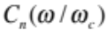 is the Chebyshev polynomial of order n.
The realization of the mathematical approximation can be done with reference to engineering handbook, where all the frequencies was normalized to 1Hz. Table I showed the design requirements for 1-dB pass band ripple Chebyshev low pass filter design requirements, the specification for each stage is shown in Fig. 2.
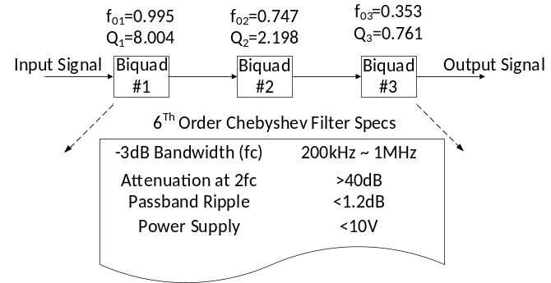
Fig. 2 Design specifications for the filter
Based on our design requirement, we want larger than 40dB/dec roll off rate after the corner frequency. So we choose 6th order Chebyshev design parameters. Based on the equation above, we can calculate the component values, which are summarized in Table I. All the resistors and capacitors are components with 1% variation.

Table I Summary of Component Values
Stage I
Target fc  (kHz) | Q1 | fc1  (kHz) | R1  (Ω) | C1  (nF)
200 | 8.004 | 199 | 80 | 10.0
400 | 8.004 | 398 | 40 | 10.0
600 | 8.004 | 597 | 26.7 | 10.0
800 | 8.004 | 796 | 20 | 10.0
1000 | 8.004 | 995 | 16 | 10.0
Stage II
Target fc  (kHz) | Q2 | fc2  (kHz) | R2  (Ω) | C2  (nF)
200 | 2.198 | 149 | 107 | 10.0
400 | 2.198 | 299 | 53.3 | 10.0
600 | 2.198 | 448 | 35.5 | 10.0
800 | 2.198 | 598 | 26.6 | 10.0
1000 | 2.198 | 747 | 21.3 | 10.0

Stage III
Target fc  (kHz) | Q3 | fc3  (kHz) | R3  (Ω) | C3  (nF)
200 | 0.761 | 70.6 | 226 | 10.0
400 | 0.761 | 141 | 113 | 10.0
600 | 0.761 | 212 | 75.2 | 10.0
800 | 0.761 | 282 | 56.4 | 10.0
1000 | 0.761 | 353 | 45.1 | 10.0

Tuning Strategy
There are many types of tuning strategies including: Gm or R tuning[3], switched capacitor based tuning[4], integrator based tuning[5], phase locked loop tuning[6], etc. These tuning processes will give a continuous tuning with a certain bandwidth. Based on our requirement, we adopt a discrete tuning process for the target corner frequency from 200kHz to 1MHz with 200kHz difference. The tuning strategy is based on resistance changing in the filter topology, which is easy to implement and insensitive to the parasitic capacitance for the board-level design. The topology is shown in Fig. 3. MOS switches are used to change the resistance values, which is easy to be controlled with digital microcontrollers for automatic corner frequency tuning. The overall filter topology can be found in the appendix.
We choose PMZ250XN from NXP Semiconductor switch with low on resistance. The frequency response of switch impedance with both on and off states is shown in Fig. 4. From the impedance plot, this type of MOS switch has stable impedance value within a wide bandwidth from 200kHz to 1MHz. We choose larger capacitor 10nF to minimize the value of the variable resistors in series to reduce the influence of MOS switch, which has only 2.7kΩ off-resistance. However, under this scenario, the MOS switch on-resistance comes into play since the variable resistor is very small with multiple switches in parallel for the control. We develop a resistor model with the MOS switch on and off impedance into consideration to calculate the resistance required for each tuning stage. The model is shown in Fig. 5. Based on this model, we derived the following mathematical equations:
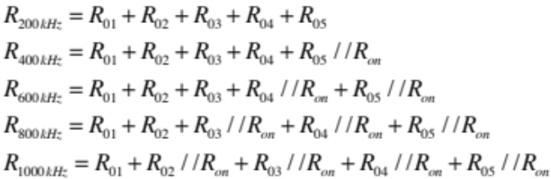

where R_{on} is 0.295Ω.
Based on the equations above, we can calculate each resistor value for each stage, which is summarized in Table II below.
Table II Resistance Values with MOS Resistance into Consideration
Stage | R₀₁(Ω) | R₀₂(Ω) | R₀₃(Ω) | R₀₄(Ω) | R₀₅(Ω)
I | 15.0 | 4.3 | 7.0 | 13.6 | 40.3
II | 20.3 | 5.6 | 9.1 | 18.0 | 53.5
III | 44.0 | 11.5 | 19.1 | 37.8 | 113

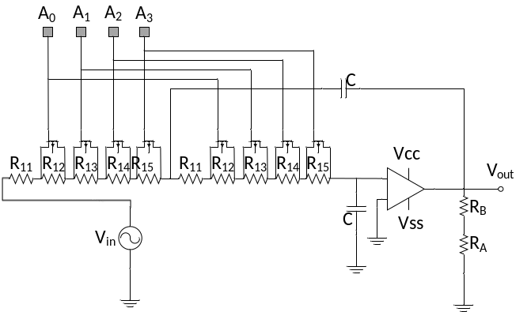
Fig. 3 Variable resistance tuning with MOS switches for a second-order KRC filter
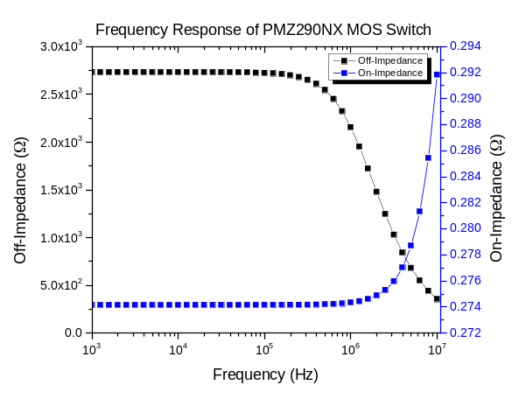
Fig. 4 Impedance frequency response of the MOS switch PMZ350XN
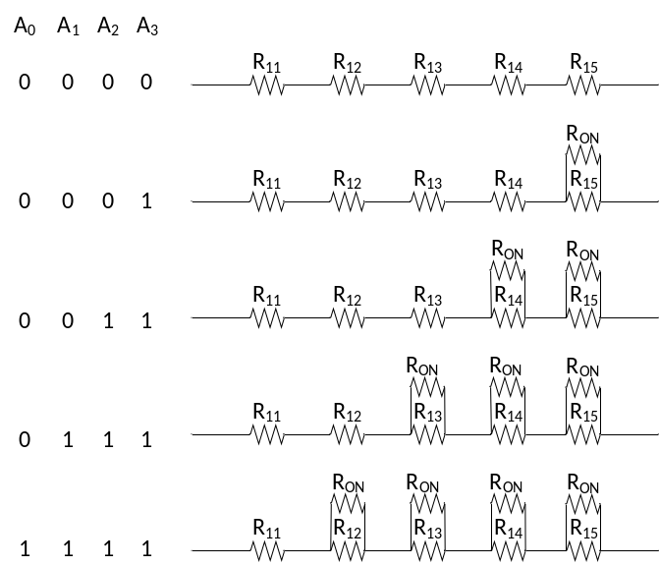
Fig. 5 Variable resistor model with switch resistance into consideration

Results

Frequency responses
The performance of this filter will be demonstrated with the following plots and tables. Fig.6 shows the frequency response of different frequencies in dB with horizontal axis in decade. Fig. 7 shows the frequency response around the corner frequency, with better view of the peaking around fc. The original plot from SPICE can be found in the appendix.
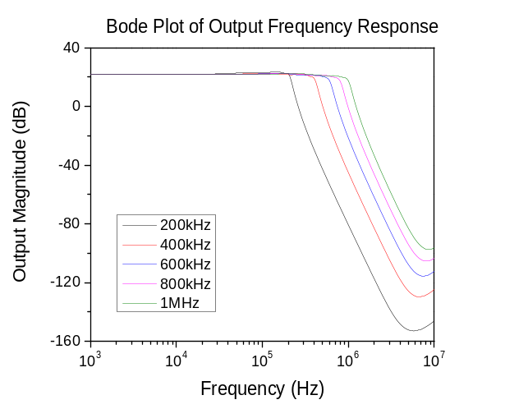
Fig. 6 Magnitude response with all frequencies
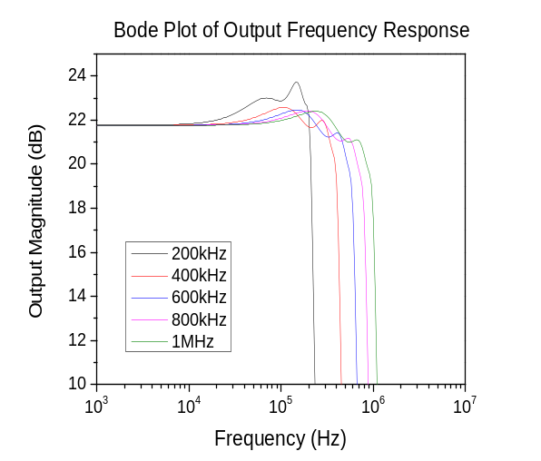
Fig.7 Magnified view of Bode plot around corner frequency

Transient analysis
The filter has been tested under various corner frequencies with different input voltages. Since the filter has a gain of around 24 V/V with the voltage rail set to be -10V~+10V, voltage peak-to-peak values have been swept from 0.4V to 0.7V. The result shows that the filter has better performance with corner frequency of 600kHz in terms of larger output voltage swing and the fewer distortion. The following plot shows the time-domain analysis under fc/2=300kHz with input peak voltage 0.5V.

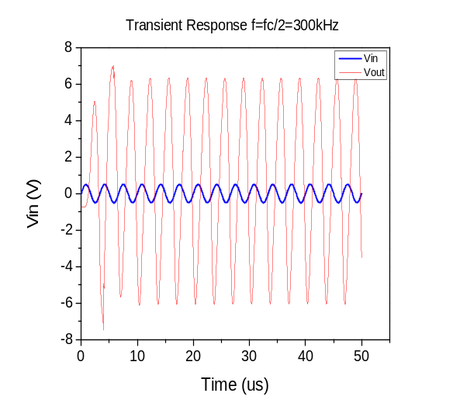
Fig. 8 Time-domain plot of output voltage at 300kHz

It should be noted that there is a DC offset of -0.46V at the output, possibly due to imperfect bias settings. The output voltage swing is reported as 5.54V to -6.81V, 12.35V in total.

Summarizing results
To sum up, the rail voltage is set to be the 10V, the highest voltage allowed in the design spec. By using cursors to measure the peaking around the corner frequency, it is determined that the ripple at the lowest fc is around 1.3dB while the ripple at 1MHz is around 1.2dB. The key performance of the filter is summarized in Table III and the cost of the components is summarized in Table IV.

Table III Summary of the Filter Performance

Design Specification | Test Results
What supply rails (voltage) did you use? | +/-10V
Element(s) you used to tune the filter. | Resistors
Passband ripple at lowest fc | 1.3dB
Passband ripple at highest fc (1MHz) | 1.2dB
Order of filter and type of response | 6th order, Chebyshev response
Total power consumption | 0.93W
Component count. How many components do you need in your design | 69
Maximum filter output swing. Please give this as a peak-to-peak voltage. | 12.35 V

Table IV Cost and Component Counts

Component | Unit Cost($) | Number | Total ($)
AD8099 | 2.66 | 3 | 7.98
PMF290XN | 0.24 | 24 | 5.76
Resistor | 0.10 | 36 | 3.60
Capacitor | 0.10 | 6 | 0.60
 |  | 69 | 17.94

Conclusion
In conclusion, a 6th order low-pass Chebyshev filter is proposed to achieve the following goals:
- Minimum 40dB attenuation at 2fc
- Maximum 1.2dB ripple in the passband
- Tunable cutoff frequency from 200kHz to 1MHz with a 200kHz step.
The 6th order filter is chosen to achieve a 1.0dB ripple with 56.7dB attenuation in theory [2]. The design has practical attenuation of 51dB and 1.2dB, which satisfies the design spec. The plots shown above demonstrate flat passband response as well as steep rolloff when frequency is beyond fc.
The filter consists of 3 KRC low-pass filters with equal component design approach. Resistor banks controlled by MOS switch are connected to opamp for corner frequency tuning. The tuning mechanisms involve DC sources in series with SPDT switches. When either of the source is disconnected, the gate of the MOS switch will be connected to the ground. Based on the combinations of switches described above, corner frequency can be adjusted. The filter has decent time-domain response, but there is DC offset and phase shift in the output. In general the design is a success, but the DC bias of the filters can be improved to obtain a better time-domain performance. In practice, microcontroller can be programmed to produce HIGH and LOW signals to control the MOS switches automatically.

Acknowledgment
We acknowledge Prof. Chris Rudell and TA Ali for their great help for this course and final project design.

References

- Ma Heping, Yuan Fang, Shi Yin, and Dai F F, “A Multi-standard Active-RC Filter with Accurate Tuning System,” Journal of Semiconductors, September 2009.
- Sergio Franco, Design with Operational Amplifiers and Analog Integrated Circuits, 3rd ed., 2001.
- V. Gopinathan, M. Tarsia, D. Choi, “Design considerations and implementation of a programmabe high-frequency continuous-time filter and variable-gain amplifier in submicrometer CMOS”, IEEE Journal of Solid-State Circuits, vol. 34, 1999.
- Jose Silva-Martinez, Michael S. J. Steyaert, Willy Sansen, “A 10.7-MHz 68-dB SNR CMOS continuous-time filter with on-chip automatic tuning”, IEEE Journal of Solid-State Circuits, vol. 27, 1999.
- David H. Chiang, Rolf Schaumann, “Design of a frequency tuning circuit used in IFLF filters”, Proceedings-IEEE International Symposium on Circuits and Systems, vol.4, 2000
- A. Yoshizawa, Y. P. Tsividis, “Anti-blocker design techniques for MOSFET-C fitlers for direct conversion receivers”, IEEE Journal of Solid-State Circuits, vol 37m 2002. M. Young, The Technical Writer’s Handbook. Mill Valley, CA: University Science, 1989.

Appendix

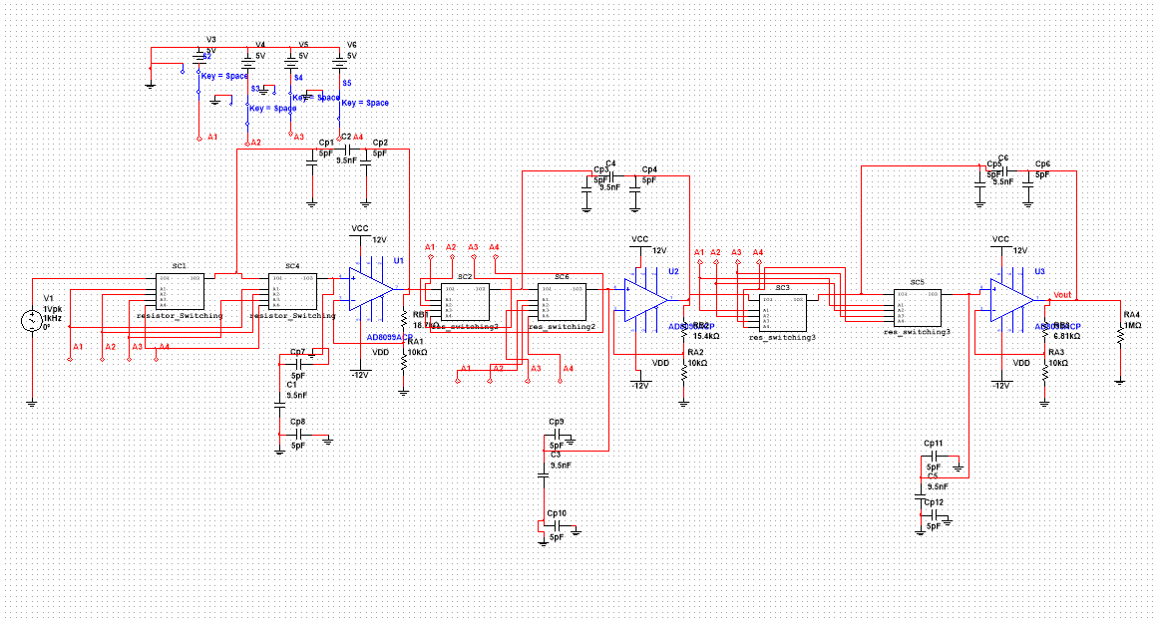

Circuit diagram

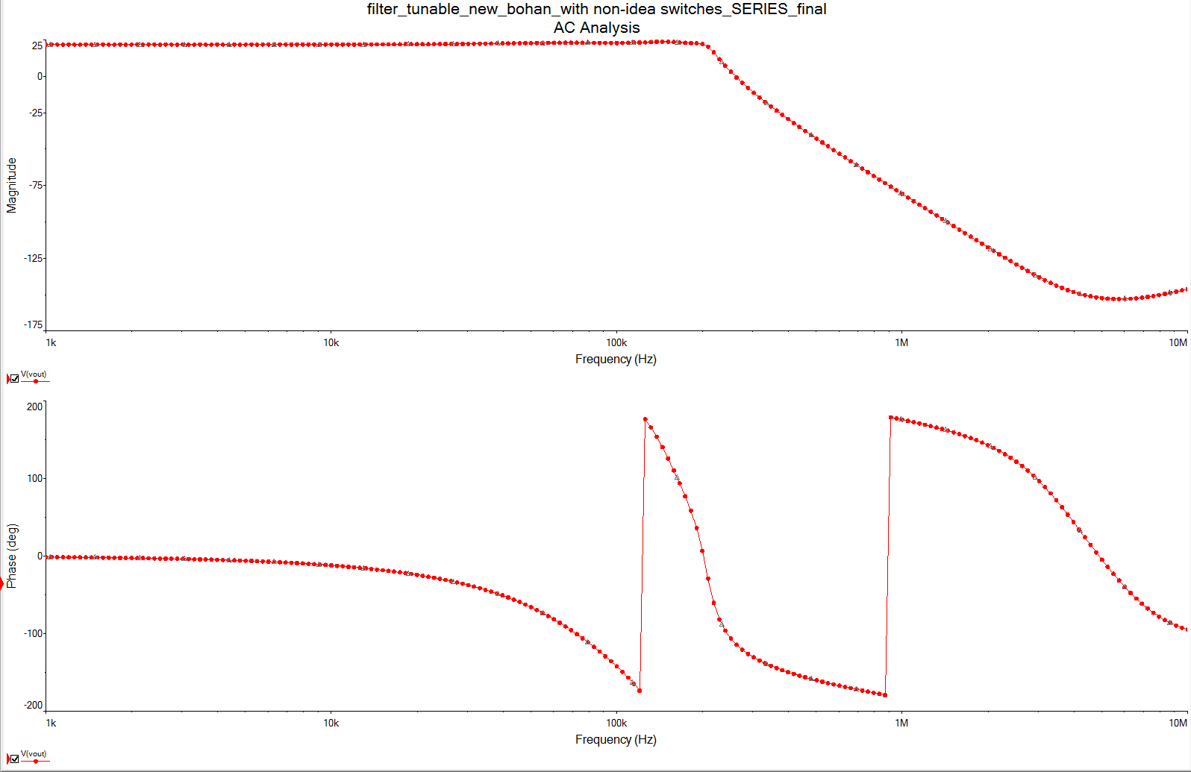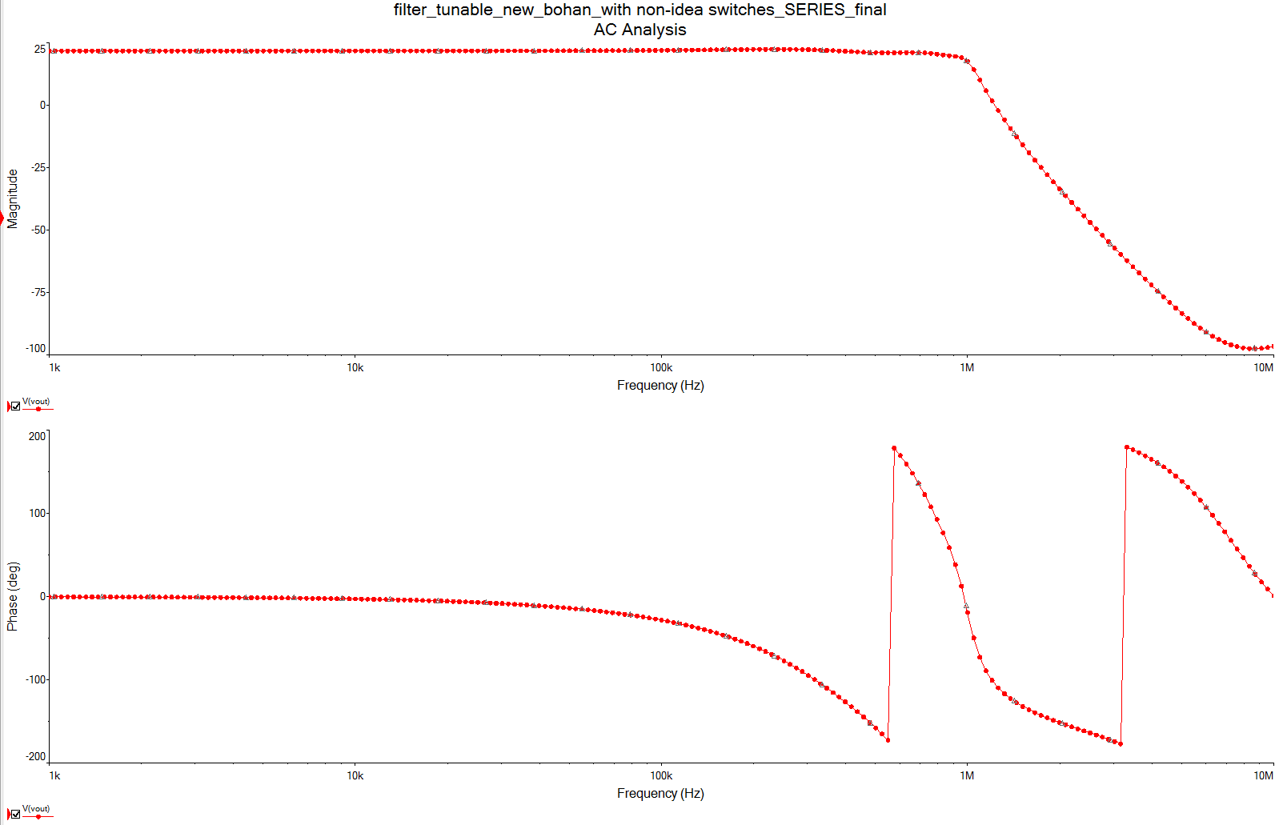

Fig. Frequency response with fc=200 kHz Fig. Frequency response with fc=1MHz
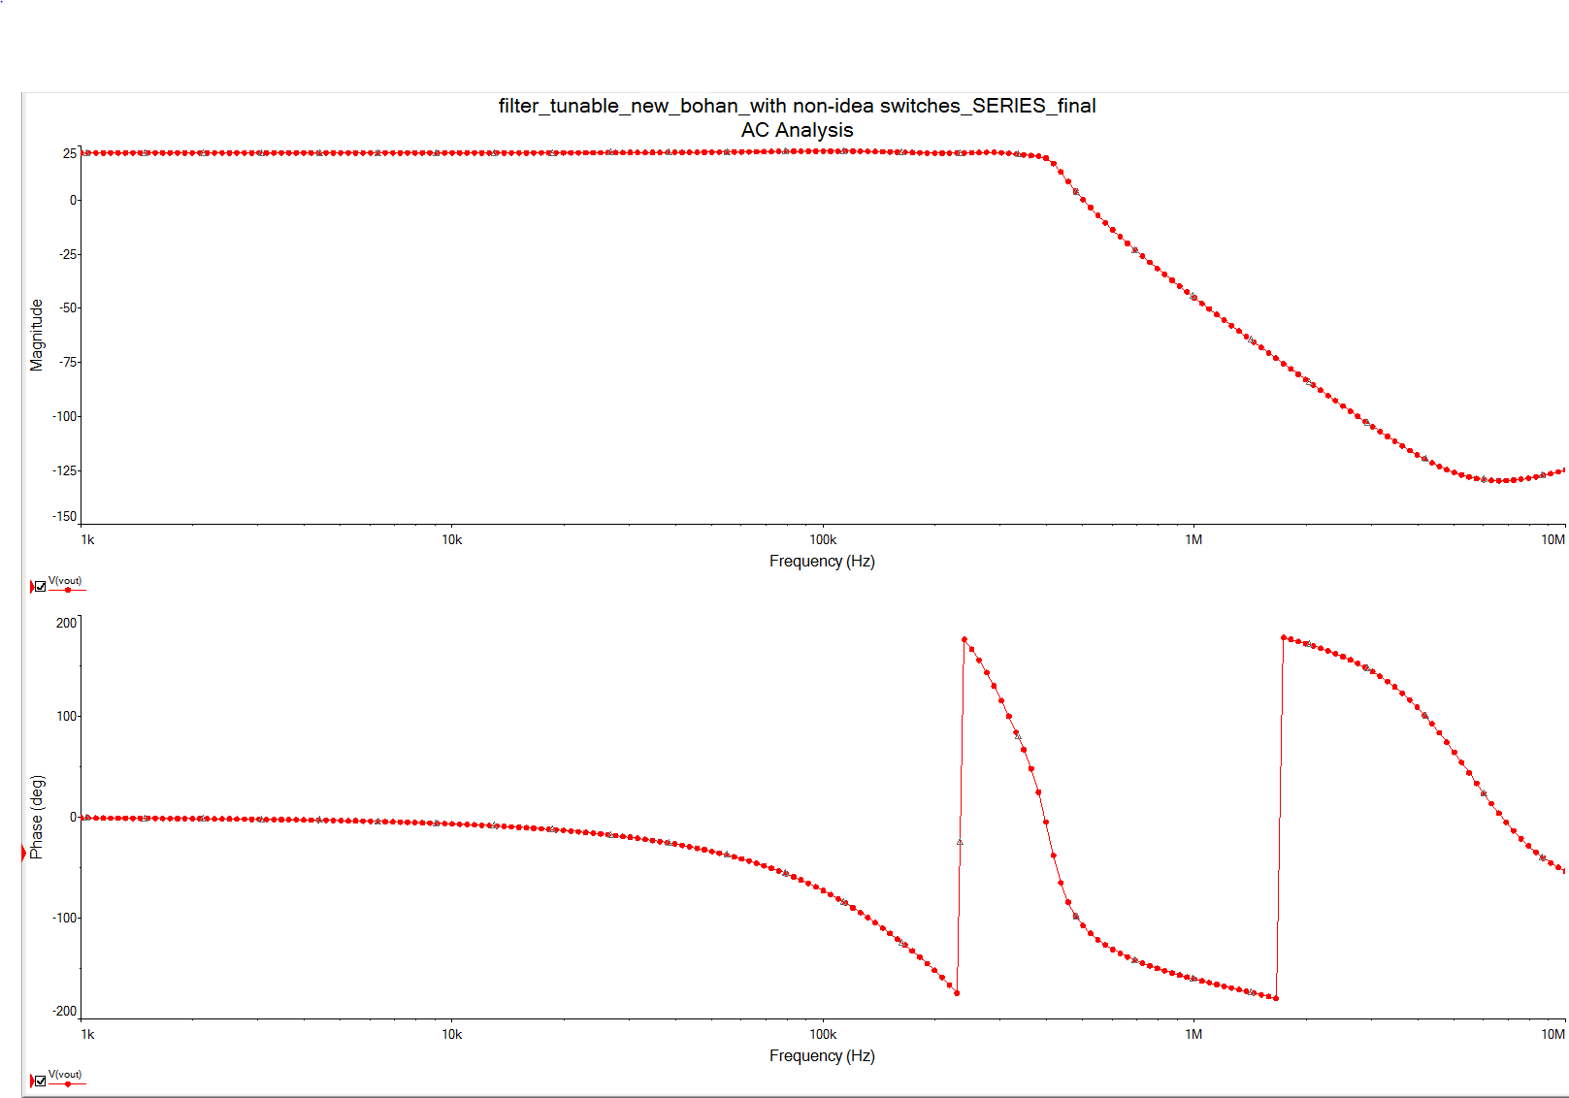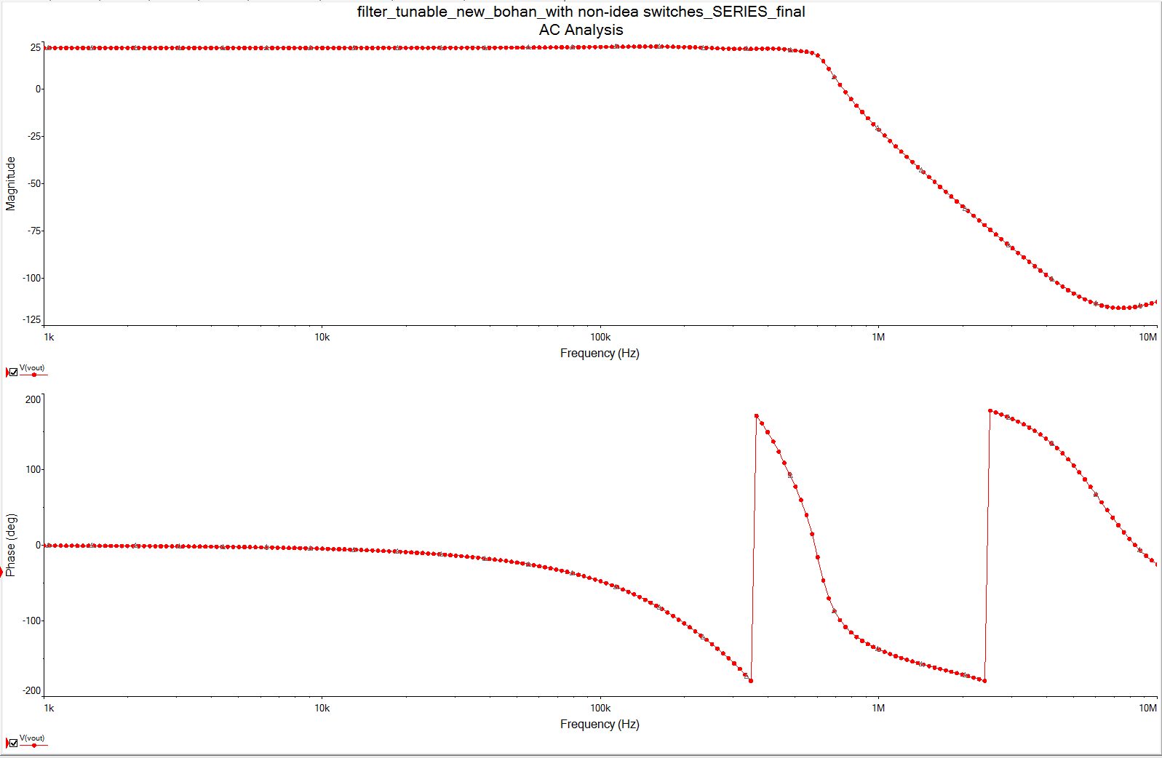

Fig. frequency response with fc=400 kHz Fig. Frequency response with fc=600 kHz

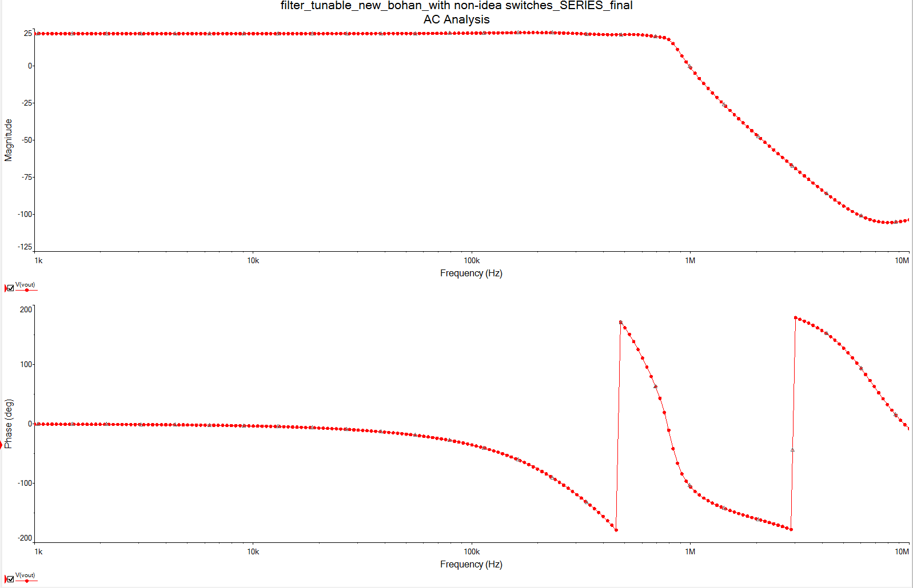
Fig. Frequency response with fc=800 kHz

